Question 4 (ERD4)
Given ERD Diagram:

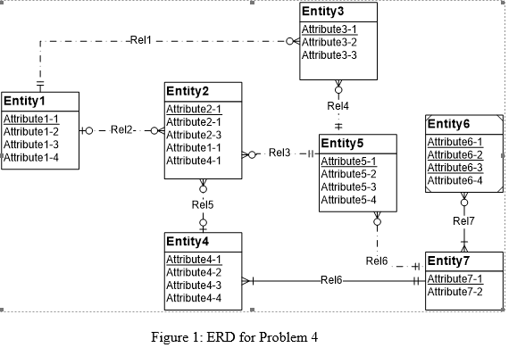
Above ERD Diagram has 5 errors:
- Identification Dependency Cardinality Rule Violation (At Rel7). Cardinality of Weak Entity should be (1,1)
- Redundant FK(Foreign Key) Rule Violation(At Rel2, Entity 2 is having Attribute1-1 which is primary key of Entity 1.
- Redundant FK(Foreign Key) Rule Violation(At Rel5, Entity 2 is having Attribute4-1 which is primary key of Entity 4.
- Identifying Relationship Rule Violation. The relationship between Entity4 and Entity7 is given identifying but none of them is weak entity.
- Attribute Name Rule Violation:Entity 2 is having 2 attributes with same name Attribute2-1.

Diagram showing Errors:
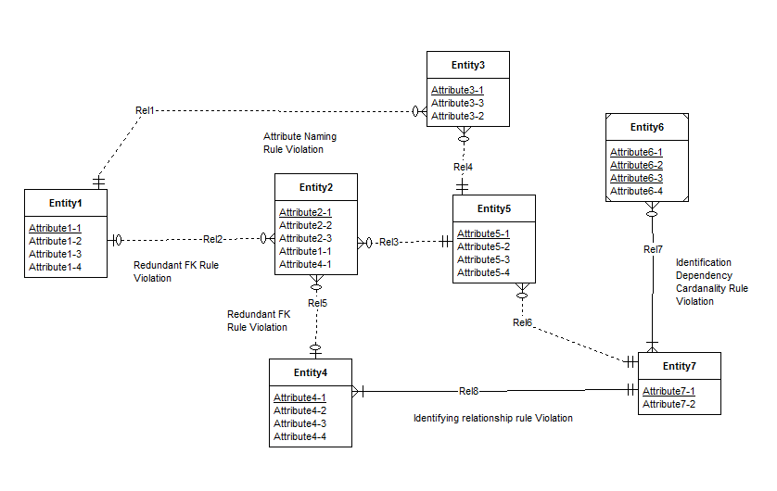

Resolution to these errors:
- Resolution of Identification Dependency Cardinality Rule (At Rel7) : Cardinality of ‘Rel7’ near Entity7 is made to be (min,max) = (1,1)
- Resolution of Redundant FK(Foreign Key) Rule (At Rel2): Remove the redundant foreign key (Entity2.Attribute1-1)
- Resolution of Redundant FK(Foreign Key) Rule(At Rel5): Remove the redundant foreign key (Entity2.Attribute4-1)
- Resolution of Identifying Relationship Rule(Relationship between Entity4 and Entity7)
:Make this relationship non-identifying.
- Resolution to Attribute Name Rule (in Entity2):
Rename the Attribute2-1 which is not primary key to Attribute2-2.

Corrected Diagram:
Next page Please…..
